LAO CAI HIGH SCHOOL FOR GIFTED STUDENTS
FOREIGN LANGUAGE GROUP

TECHNIQUES FOR DESCRIBING GRAPHS

TABLE OF CONTENT
TABLE OF CONTENT 2
I. INTRODUCTION 3
1. Rationale 3
2. Purposes of the paper 4
III. DEVELOPMENT 4
1. Literature review 4
2. Techniques for describing graphs 4
2.1. A brief introduction 4
2.2. How to describe graphs 5
2.3. Writing assessment 22
III. CONCLUSION 25
REFERENCES 26

I. INTRODUCTION

1. Rationale
It is necessary to have a clear understanding of the manner in which graphs are introduced in written communication. That’s why many subjects constitute an important area for pictorial and graphical presentation. Apart from that, graphs are used extensively in brochures, sales literature, booklets, advertisement, motivational communication, etc. The positioning of graphs has to be carefully decided. In doing so, it is essential to keep in mind the value addition taking place as a result of the insertion of the table or chart. The skill of the communicator, however, lies in introducing an adequate number and variety of charts, graphs and pictures along with the text in such a way that the overall impact is high.
As for students, writing is one of the most difficult skills but it is also a very important skills. Teaching writing is normally a challenge for many teachers, expecially, teaching writing graphs, a field which requires both writing and interpreting data. To help studend achieve a better understanding of graph writing, this paper will provide an overview of graphs and some techniques for interpreting and describing graphs.

Purposes of the paper

The paper focuses on two main sections, which aims at providing the readers with the review of academic writing and graph description. In section two, the paper discusses in detail some steps, and techniques for describing graphs, criteria of assessment in real writing.

II. DEVELOPMENT

1. Literature review
This section investigates the literature relevant to the topic. The literature review begins with an overview of graphs and then discuss the aspects of teaching writing skills.
Carol Kanar (2008) defined graphs as graphics which are written or pictorial representations of data. Pie charts, line or bar graphs, and tables are commonly used in illustrating statistics. To interpret a graph, Robert L. Haris (1996) states that it is required for readers to understand how a chart or graph is constructed and functioned. Being able to understand and describe graphic information is an important academic skill. You need to show that you can interpret this type of factual information clearly and accurately. (Vanessa Jakeman and Clare McDowell, 1999)
Writing is considered one of the most difficult skills in for students in EFL/ ESL to approach. Gardner and Johnson (1997) argue ‘Writing is a fluid process created by writers as they work…. In actuality, the writing process is not a highly organized linear process, but rather a continual movement between different steps of the writing model’(p.36). In EFL/ESL classrooms, product and process approaches have dominated much of the teaching of writing over the last 20 years. In the last ten years, we have seen the growing importance of genre approaches in the EFL/ESL classrooms.

2. Teachniques for describing graphs

2.1. A brief introduction

2.1.1. Introduction
Graph writing, in fact, is a way to transfer information into written language from a graph or a chart. The word “Graph” refers to Graphs, Charts, and Tables. Graphs and charts are pictures which show numbers or fingures, and tables are just rows and columns of information.

2.1.2. Main types of graphs
+ Line graphs: The most common type of graph is the line graph. It is a graph which use one ore more lines to show changes in statistics over time and space. It highlight trends.
To interpret this kind of graph, you should answer below questions:
- What period of time does the horizontal axis show?
- What information does vertiacl axis show?
- What does the line represent?
- What tense do you need to use to describe this information?
- What main changes does the line graph illustrate?
- What are the lowest and the highest fingure?
Here is an example of line graphs:
Consumption of Fast Food in the UK in Grams per Week, 1970 to 1990
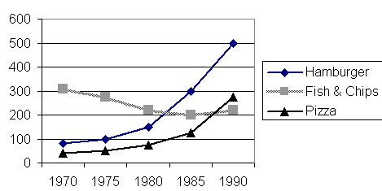

Fast Food UK; Quantity

+ Bar graphs (bar charts):
A bar graph is a visual display used to compare the amounts or frequency of occurrence of different characteristics of data.
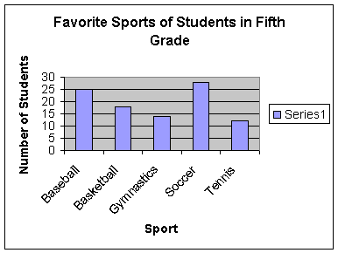
+ Pie graphs (pie charts)
Pie graphs (pie charts) is a circular chart which is divided into sectors in which the area of each sector represents the size of the data.
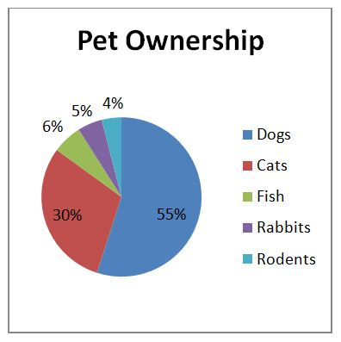
+ Mixed graphs:
Mixed graphs are the combination of two or more charts/ graphs/ table.
Example of mixed graphs:
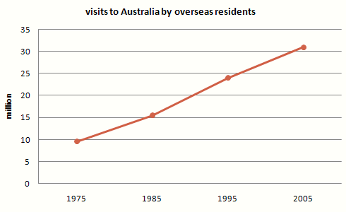

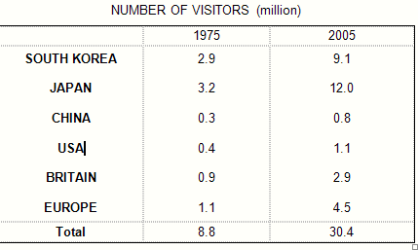

The given line graph illustrates information on the number of overseas visitors traveling to Australia in millions of people while the second table gives statistics showing the countries whose residents went to Australia between 1975 and 2005.

* Note:
In the case of a line graph, the horizontal and vertical axes provide most of the information. Usually trends over a specific period of time are shown in this way. A bar graph shows the same kind of information but with the units presented as bars or columns. Another kind of bar graph (also called a histogram) may show numerical distributions rather than changes. Pie graphs show proportions, normally represented as percentages.

2.1.3. The structures of a graph report
The information must be presented accurately and coherently. Expecially, the organization is of logical pharagraphing with an introductory paragraph, body paragraphs, and a concluding paragraph.
The report should consist of three parts:
- Introduction: 1 paragraph (1-2 sentences). The introductory sentence (s) should explain what you are describing. Say what the graph shows in your own words
( you will lose mark if you copy the question).
- Body: 2-4 paragraph. When describing the date presented in the task, identify significant trends and give examples that relate directly to the given information to support your statements. If you are explaining a process or and object and how it works, you need to group your information so that it follows a definite logical order. Remember that the use of verbs expressed in the present (present simple or present perfect) passive voice is often appropriate when giving a description of a process. The secret here is to select what is is important, organize it, and compare and contrast.
- Conclusion: 1 paragraph (1-2 sentences). The conclusion should sum up the global trends shown on the fingure and compare them if possible. Remember no explanation, reason or personal comments should be given.

2.2. How to describe graphs

2.2.1. Wrtiting the introduction
The introduction should describe the purpose of the chart and say what overall trends can be seen. In the introduction part you should focus on the following information:
WHAT is described in the graph?
WHERE was the data collected?
WHEN was the data collected?
WHAT are main features of the graph?
* Some useful expressions:
The pie chart  line graph  bar chart  table  flow chart  ............... | gives information about /on  represents information on  shows/describes  compares/indicates  illustrates/demonstrates | WHAT | WHERE | WHEN
It is clear from the graph/table  It can be noted from the graph  As can be seen from the graph/table  As the graph/table shows  As is illustrated/shown by the graph/table  From the graph/table it is clear |  | that........(main features)
Notes:
+ Notice the tense used. Even though it describes information from the past, the graph shows the information in the present time.
+ Notice that if you copy the same opening sentence as in the questions, that sentence will not be accessed by the examiner. Try to use your own words (paraphase or utilize synonyms of the topic words)
+ Don’t use personal pronouns such as “As you can see from the chart” or “We can see that...”
+ Avoid using the phrase: according to the graph. This is because the phrase “according to” generally means that the information comes from another person or source, and not from our own knowledge.
+ The word present is best avoided, since it requires a sophisticated summarising noun to follow.

2.2.2. Writing the body part
Each body paragraph must contain the following points:
+ Complete sentences are used in describing the given information
+ When discussing the data presented in the task, identify significant trends and give examples that relate directly to the given information to support your statements.
+ The use of verbs expressd in the present passive voice is often appropriate when giving description of a process or produce.
To complete the body parts, it is recommend to look at some useful expressions below:
2.2.2.1. Describing trends:
Trends are noticeable changes in a situation or in the way something usually behaves. To describe the movement, there is some language which will always be useful. Below is a list of language you can use.. As you will see, there are a number of words which are similar in meaning. This means that you will be able to use a variety of vocabulary which gives a good impression to the examiner who will read and mark your writing.
 | NOUNS | VERBS | PHRASES
 | - a rise  - an increase  - a surge  - a growth | - to rise  - to increase  - to surge  - to grow  - to go up  - to soar  - to rocket | - to show an upward trend
 | a fall  a drop  a decline  a dip  a plunge  a decrease | to fall  to drop  to decline  to dip  to plummet  to go down  to plunge  to decrease | - to show a downward trend  - to hit the lowest point  - to hit a trough
 | a peak | to peak | to reach a peak
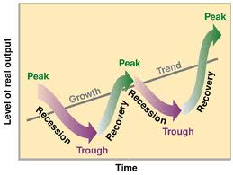 | -a fluctuation  -a variation | to fluctuate  to vary | to show some fluctuation/  variation
 | a period of stability | to stablise | -to remain unchanged/ stable/ constant
 | -a plateau  -plateaux | to plateau | -to reach a plateau  to level off/out  to flatten out

2.2.2.2. Expressing comparision:
Graphs and tables are generally intended to show comparisons, contrasts or correlations. In some cases a variety of things are compared or contrasted, while in other cases the same items are compared at different times. This is done to show movement or trends. This section will deal with comparisons of different items, while the next section, on trends, will deal with changes over time. We will then look at how correlations are used and interpreted.
Note that the verb to compare means to show both the similarities and the differences between two things, while to contrast means simply to reveal the differences. It is therefore enough to use compare or both purposes.
+ Comparing and contrasting data
Simple comparatives:
A | is (not) | adj-er | than |  | B
A | is (not) | more adj | than |  | B
A | is (not) | as | adj | as | B

Comparative structures to compare fingures
There + be  (not) | significantly  considerably  far  slightly | fewer  more  less | (Noun) | than......
There + be  (not) | nearly | as | many  much | (Noun) | as ......
There + be  (not) | almost/ more than | twice/ three times as | many  much | (Noun) | as ......

Simple superlatives
A | is | the | adj-est | in/ of....
A | is | the | more adj | in/ of....
Superlativestructures to describe fingures
The | biggest | increase | is/ was (in/from)....
The | largest | number of... | is/ was (in/from)....
The | smallest | percentage of... | is/ was (in/from)....
The | most significant | proportion of | is/ was (in/from)....

+ Expressions of fraction
Approximating fingures | Fractions
(just) over  around  about  approximately  approaching  almost  (just) under  (slightly) more/ less than | half  a third  two thirds  a quarter  three quarters  a fifth  a tenth

+ Incorporating data
There are four ways of incorporating data:
- Subject + appropriate verb
Women made up a significant percentage of the workforce.
- Brackets ( )
The other colors, which cpnstitute 3.12, are considerably less popuplar than blue (12, 72 %).
- A relative clause (which + appropriate verb)
Red, which accounts for 28, 05 %, is about twice as popular as blue, which is 12, 72 %.
- Participal phrases
The other colors, which is 2 %, are considerably less popular than blue, accounting for 12, 72%
Some verbs and phrases to express incorporating data
make up  constitute  stand at  comprise  account for  record  consist of  amount to  represent | nearly half of  ...% of ...  the majority of....  a significant percentage of....

+ Compare and contrast connectors
Similarity | Contrast
In the same way  Both...and  Also  As.....as  Likewise  The same  As well as  Just as/ like X, (so) Y.....  In a similar way  Not only....but also | But  However  Nevertheless  Yet  On the other hand  Unlike  While  Whereas  Although/ even though  As opposed to  In contrast to  By contrast  Apart from

+ Other expressions of comparing and contrasting
Contrast can also be shown by using specific verbs, adjectives and nouns:
Verbs | Adjectives | Nouns
compare (with / to)  contrast (with)  differ (from)  differentiate (between)  distinguish (between)  resemble  vary (from/ between)  change (from/ to) | compared (with / to)  contrasting  different (from)  distinct from  same  the same as  similar to | comparison  in comparision with  contrast  in contrast  in con trast to  difference (between)  distinction (between)  resemblance (to/ with)  similarity (with)  variation (between)  change (from)
Note:
Cornpared and carnparing are often used incorrectly. Look at these sentences:
Compared with x, y is moref ficient.
Comparing x with y we find that x is more eficient.
Comparing with x, y is more fficient.
Two of three above are ceffect and one is incorrect. People compare things (or people). If the active voice is used (comparing) then it must refert o someoned oing the comparing- i.e. people. So we say:
Comparing x with y we find that...
Comparing x with y it can be seen (by us) that,,..
If the person or people doing the comparing are not relevant to the sentence, then the passive form (comparing) must be used. So the first two sentences are correct, but not the last one.
2.2.3. Writing conclusion
A simple concluding statement may include any of the following points:
+ significant comment
+ an overall summary of the key point
Connectors to signal conclusion | Content
In summary,  To sum up,  In short,  In conclusion,  To conclude,  On the whole,  Altogether, | Express the main points of the illustration again in your own words.  Say something new that does not extend too far beyond what the illustration shows. You can metion future implications or draw a conclusion.

Therefore,  Thus,  On this basis,  Given this, | it | can  may | be | concluded  deduced  infered | that..........

2.2.4. Tenses and Voices
It is important to select the correct tenses.
Points to remember:
a) For most visuals a specific time in the past will be given and you will need to use the past simple tense. If two things took place at the same time, you may use the past continuous tense for one of them.
b) If you use since or recent(ly) it means that you are referring to eve nts that have come up to the present. That means using the present perfect tense.
c) With by you will often need to use the past perfect or the future perfect tense.

Sample of writing a report on the pie chart:
It is often claimed that women have achieved greater freedom and have access to the same opportunities as men. The pie chart below show some employment patterns in a developed country.
Write a report for a university lecturer describing the information in the chart. below. You should write about 150 words.
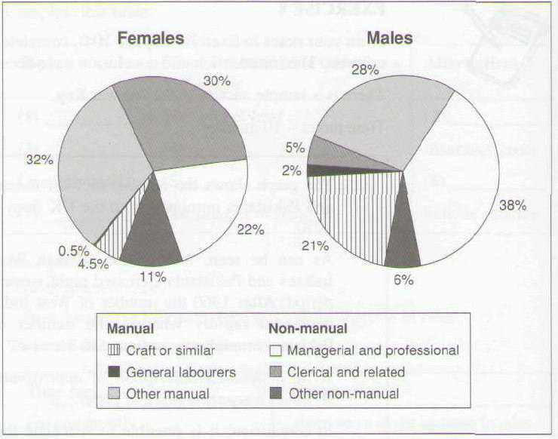
Steps 1: Preparation (Analysis)
Time: Not given – present tense
Subject: Employment
Trends: +More men than women engaged in managerial and professional, craft
+ Fewer men in clerical and related work
+ same number for man and women in managerial and professional
Details: + Non-manual section: more women in clerical; more men in managerial and
professional; the same in other work
+ Manual section: men in most craft and general labour; the same in other work
Step 2: Writing
Remember three part (Introduction- body- conclusion)

+ Introduction:
The two pie charts show the proportion of males and female in employment.....
(Describe the general trend)
+ Body:
Paragraph 1: Describe and compare, contrast in non-manual section
In the non-manual occupations, while a greater percentage of working women than men are found in clerical-type positions, there is a smaller percentage of women than men employed in managerial and professional positions....
Pargraph 2: Describe and compare, contrast in manual section
In manual employment, the biggest difference between the two sexes is in the employment of craft workers, where makes make up 21% of the workforce and females just 4.5%.
+ Conclusion:
Sump up the key point.
In conclusion, the two charts clearly illustrate that women do not have the same access as men to certain types of employment.
Step 3: Editing
Make sure that you have followed the instructions carefully. Be sure that you have written what you intended and that no important idea are missing.
Check for obvious mistakes such as spelling and gramatical errors.
Read again to check whether the writing is logical or not.

Model writing:
The two pie charts show the proportion of makes and females in employment in 6 broad categories, divided into manual and non-manual occupations. In general, a greater percentage of women work in non-manual occupations, and the reverse is true for men.

In the non-manual occupations, while a greater percentage of working women than men are found in clerical-type positions, there is a smaller percentage of women than men employed in managerial and professional positions. The percentage of women employed in other non-manual occupations is slightly larger than the percentage of men in these occupations.

In manual employment, the biggest difference between the two sexes is in the employment of craft workers, where makes make up 21% of the workforce and females just 4.5%. Furthermore, the percentage of women working as general labourers is very small, only 0.5%. there is not a great deal of difference between the percentage of men doing other forms of manual work (28%) and women in other manual work (32%).

In conclusion, the two charts clearly show that women do not have the same access as men to certain types of employment.
(186 words)

2.3. Writing assessment
The assessment of writing is based on the ablility to:
- organise, present and possibly compare data
- describe the stages of a process or procedure
- describe an object or event or sequence ofevents
- explain how something works
There are many ways and criteria of assessing and evaluating a writing. This sections will introduce one of the effective methods which is called “Using ribric”
Here is an example of writing rubric which is used to assess a graph writing
Students will get 1-5 points for each of the answer to the following questions as very bad, bad, acceptable, good, very good
CRITERIA |  | Very bad  1 | Bad  2 | Acceptable  3 | Good  4 | Very good  5
Task fulfillment | Does the writing follow the right format?
Task fulfillment | Does it present a clear overview of main trends/ main features?
Task fulfillment | Does it highlight key features that are well supported with accurate data?
Coherence  and  cohesion | Are the ideas logically organized?
Coherence  and  cohesion | Does the writing include a wide range of vocabulary that is relevant?
Lexical  resource | Does the writing employ linking and reference words?
Lexical  resource | Does the writer have correct spelling, word formation and collocation?
Grammatical  range and  accuracy | Does the writer use accurate verb tenses and verb agreement?
Grammatical  range and  accuracy | Does the writer use a wide range of sentence types/ structures, both simple and complex?
Grammatical  range and  accuracy | Does the writer use appropriate punctuation?
Total score

III. CONCLUSION
Interpreting and reporting graphic information is still a challenge for most of EFL learners which, more or less, affects the learning outcomes. The problems of teaching EFL writing can be found in such questions as how to make EFL students aware of the purposes of graphs, some useful techniques for describing, and the criteria to assess students’ writing. It is hoped that the solutions provided in this article will be of use for later improvements in the teaching and learning of EFL writing in general, especially in writing graphs.

REFERENCES
E. M. White, Teaching and assessing writing (2nd), Jossey-Bass Publishers, San Francisco, 1994.
G. Cook. Applied linguistics, Oxford University Press, Oxford, 2003.
Gabi Duigu (2001). Visuals Writing about Graphs, Tables and Diagrams: Academic English Press.
Jakeman, V.(2003). Insights into IELTS Extra.Ho Chi Minh city: Ho Chi Minh Publishing house.
L. Flower, J. R. Hayes, A cognitive process theory of writing, College English 44 (1981)
Stevens, D. D., & Levi, A. J. (2005). Introduction to rubrics: An assessment tool
to save grading time, convey effective feedback, and promote student learning. Sterling, VA: Stylus.
Slater, S. & Millen, D.(2003).IELTS on Track. Ho Chi Minh City: Ho Chi Minh Publishing house.
Todd, V. & Cameron, P.(2003. Prepare for IELTS. Sydney: Insearch Language centre. University of Sydney.
Wilson, M. (2006). Rethinking rubrics in writing assessment. Portsmouth, NH:
Heinemann.
Xia H. W.(2012). 15days’practice for IELTS writing. HCM City: Hồ Chí Minh Publishing House.
Vanessa Jakeman & Clare McDowell.(1999). New insight into IELTS. Cambridge Universiy Press.

